One Helix Pipes & Tubes – Plant Operations SOP

Scope: This document provides Standard Operating Procedures (SOPs) for the complete manufacturing process of One Helix Pipes & Tubes, covering the workflow from HR Coil purchase and receipt through finished goods sales and yield calculation. This SOP is designed to guide the Plant Operations Team in tracking and managing the entire production lifecycle using the Pipes_and_Tubes-Operations.xlsx tracking system.

Responsibilities | Maker | Checker
HR Coil inspection | SGS Person | Sanjay Jha
HR Coil Tracking in master sheet | SGS Person | Sanjay Jha
Baby Coil Tracking | SGS Person | Sanjay Jha
FG Tracking | SGS Person | Sanjay Jha
FG Sales data Tracking | SGS Person | Sanjay Jha

Document Sections:
- A.1 - HR Coil Purchase & Receipt

- A.2 - HR Coil Tracking

- A.3 - HR Coil Slitting & Baby Coil Tracking

- A.4 - FG Conversion & Tracking

- A.5 - FG Sales/Dispatch Data

- A.6 - Yield & Loss Calculation

A.1 HR Coil Purchase & Receipt
This section describes the process for receiving and recording Hot Rolled (HR) coils procured from approved suppliers at the One Helix Pipes & Tubes manufacturing facility. Upon receipt, all coil details are recorded in the HRC PO sheet, and data will flow from this sheet to the coil sheet.
Activity | Steps | Team | Interface / Utilities Used
1. HR Coil Purchase & Receipt | 1. Receive HR coil delivery from approved supplier at plant facility  2. Verify physical condition of coil  3. Match delivery challan/invoice with purchase order  4. Confirm coil specifications against order details  5. Accept coil into inventory  6. Proceed to coil tracking and data entry | Plant Operations Team/SGS Team | Pipes_and_Tubes-Operations.xlsx  Sheet: "HRC PO Sheet"  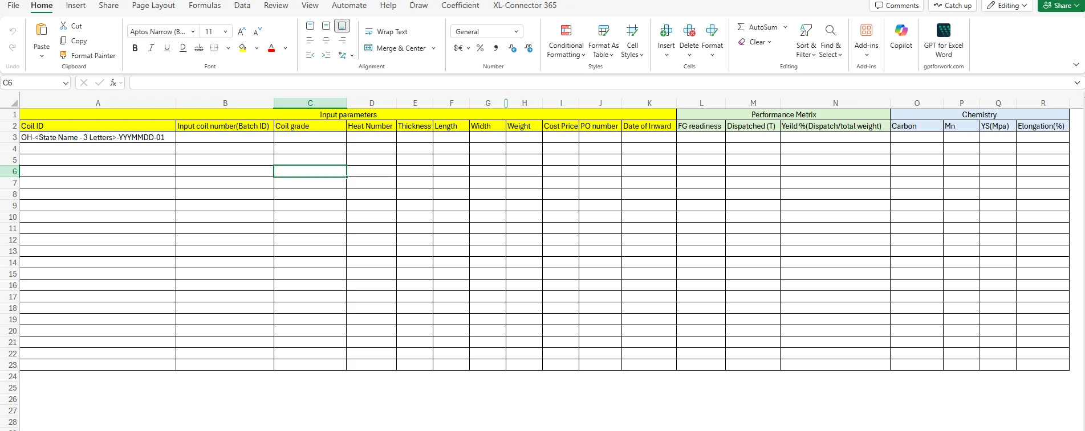

Key Process Notes:
- HR coils must be physically inspected for damage before acceptance
- Delivery documentation must be verified against the purchase order
- Only coils meeting quality specifications should be accepted
- Upon acceptance, the coil proceeds to the tracking process (Section A.2)

A.2 HR Coil Tracking
This section describes the process for recording detailed information of each HR coil in the Master Sheet (Coil sheet). All data entered in this step forms the master record. For tracking purposes, the plant team selects the HR Coil ID from a dropdown list linked to the Master Sheet, and the coil details are automatically populated in the HR Coil Tracking Sheet to ensure traceability throughout the manufacturing process.
Activity | Steps | Team | Interface / Utilities Used
2. HR Coil Data Entry & Tracking | 1. Open Pipes_and_Tubes-Operations.xlsx file  2. Navigate to "Coil Sheet" tab  3. Generate HR Coil ID using format: OH-<State Name - 2 Letters>-YYYYMMDD-Sequence number  Example: OH-HR-20250115-01  4. Enter the Input Coil Number (Batch ID) from supplier documentation  5. Enter Coil Grade (e.g., JSW-SPHC, JSW-SPHD)  6. Enter Heat Number from coil identification markings  7. Enter Thickness (in mm) from specifications  8. Enter Length (in mm) from specifications  9. Enter Width (in mm) from specifications  10. Enter Weight (in kg) from weighbridge or documentation  11. Enter Cost Price per coil  12. Enter Purchase Order (PO) Number  13. Enter Date of Inward (receiving date)  14. Verify all entries for accuracy  15. Save the file | Plant Operations Team | Pipes_and_Tubes-Operations.xlsx  Sheet: "Coil sheet"  

Coil ID Generation Logic:
- Format: OH-<State- 2 digits>-YYYYMMDD-##
- OH: One Helix prefix
- State: Two-letter state code (e.g., HR for Haryana, UP for Uttar Pradesh)
- YYYYMMDD: Date of receipt (Year-Month-Day)
- ##: Sequential number starting from 01 for each day
Example: OH-HR-20250115-01 (First coil received on January 15, 2025, in Haryana)

Critical Notes:
- The HR Coil ID must be unique and follow the standardized format
- All dimensional and weight data must be verified against supplier documentation
- This master data will auto-populate in subsequent slitting and conversion processes
- Ensure data accuracy as errors will cascade through the entire production chain

A.3 HR Coil Slitting & Baby Coil Tracking
This section describes the process of slitting HR coils into smaller width coils (called "Baby Coils") and tracking each baby coil in the system. This is a critical step where one HR coil is divided into multiple baby coils for further processing.
Activity | Steps | Team | Interface / Utilities Used
3. HR Coil Slitting & Baby Coil Data Entry | 1. Open Pipes_and_Tubes-Operations.xlsx file  2. Navigate to "Coil to Slit" tab  3. Enter Date of Conversion (slitting date)  4. Enter Thickness and Width to be slit. Based on the entered parameters, the relevant HR Coil ID appears in a filtered dropdown. Select the applicable HR Coil ID  5. Generate Baby Coil Entries as A, B, C, D... for each slit section  • Enter A for first baby coil  • Enter B for second baby coil  • Continue sequentially (C, D, E...)  6. Baby Coil ID auto-generates by concatenating:  HR Coil ID + "-" + Baby Coil Entry  Example: OH-HR-20250115-01-A  7. Thickness and Length auto-populate from master coil data  8. Enter Width (in mm) for each baby coil after slitting  9. Weight auto-calculates using formula:  Weight = Thickness × Length × Width × Material Density  10. Cost Price, PO Number, and Date of Inward auto-populate from master data  11. Verify all entries for accuracy  12. Repeat steps 5-11 for each baby coil from the same HR coil  13. Save the file | Plant Operations Team | Pipes_and_Tubes-Operations.xlsx  Sheet: "Coil to Slit"  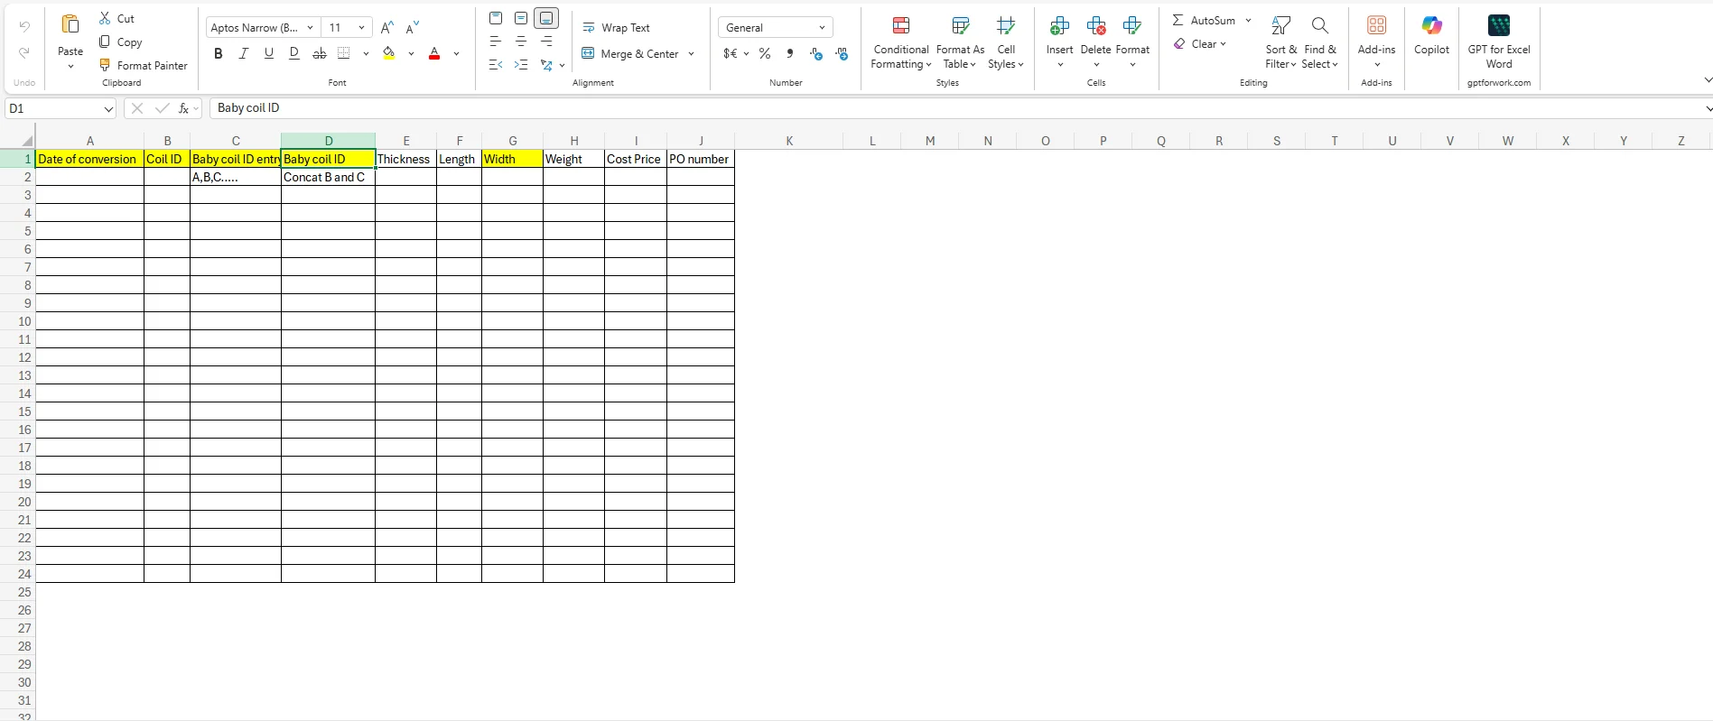

Baby Coil ID Generation Logic:
- Format: [HR Coil ID]- [Baby Coil Entry]
- Example: OH-HR-20250115-01-A

Critical Process Notes:
- Each HR coil typically produces multiple baby coils depending on slitting requirements
- Baby coil entries must be sequential (A, B, C...) for proper tracking
- The sum of all baby coil widths should approximately equal the original HR coil width (accounting for wastage)
- Weight calculations are automatic but should be verified against actual weighbridge measurements
- Baby Coil IDs created here will be used in the FG Conversion process (Section A.4)

A.4 FG Conversion & Tracking
This section describes the process of converting baby coils into finished goods (FG) bundles. Each baby coil is processed into multiple bundles based on SKU specifications, with each bundle representing a saleable unit of pipes/tubes.
Activity | Steps | Team | Interface / Utilities Used
4. FG Conversion & Bundle Creation | 1. Open Pipes_and_Tubes-Operations.xlsx file  2. Navigate to "FG Conversion" tab  3. Enter Date of Conversion (FG production date)  4. Select SKU Code from dropdown menu  • SKU codes are pre-defined based on product specifications  • Example: SKU-P25-100 (Pipe, 25mm thickness, 100mm width)  5. Baby Coil ID is auto-populated from the "Coil to Slit" sheet based on the selected SKU Code  6. Generate Bundle ID Entry as 01, 02, 03... for each bundle  • Enter 01 for first bundle from this baby coil  • Enter 02 for second bundle  • Continue sequentially (03, 04, 05...)  7. Bundle ID (Unique ID) auto-generates by concatenating:  Baby Coil ID + "-" + Bundle Entry  Example: OH-HR-20250115-01-A-01  8. Enter Number of Pieces per bundle  9. Enter Length (in mm) of each piece  10. Width and Thickness auto-populate from baby coil data  11. Enter Weight (in kg) of the completed bundle  12. Verify all entries for accuracy  13. Repeat steps 6-12 for each bundle from the same baby coil  14. Save the file | Plant Operations Team | Pipes_and_Tubes-Operations.xlsx  Sheet: "FG Conversion"  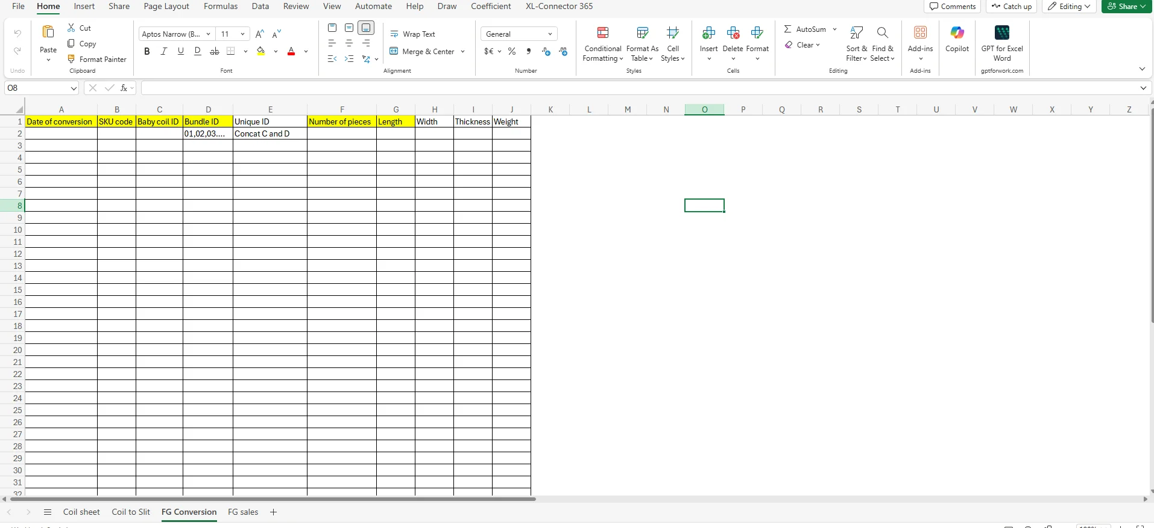

Bundle ID Generation Logic:
- Format: [Baby Coil ID]-[Bundle Entry Number]
- Example: OH-HR-20250115-01-A-01

Critical Process Notes:
- Each baby coil can produce multiple bundles depending on production requirements
- Bundle entries must be sequential (01, 02, 03...) for proper tracking
- SKU Code selection determines the final product specifications
- Bundle IDs created here will be used in the FG Sales/Dispatch process (Section A.5)
- Weight should be verified against theoretical weight for yield calculation purposes
- Each bundle represents a complete, saleable unit ready for dispatch

A.5 FG Sales/Dispatch Data
This section describes the process of recording finished goods sales and dispatch information. This is the final stage before products leave the facility, where actual dispatch weights are captured and compared against theoretical weights to calculate yield.
Activity | Steps | Team | Interface / Utilities Used
5. FG Sales/Dispatch Recording | 1. Open Pipes_and_Tubes-Operations.xlsx file  2. Navigate to "FG sales" tab  3. Select SKU Code from dropdown menu  • Must match the SKU from FG Conversion process  4. Select Baby Coil ID from dropdown (linked to "FG Conversion" sheet)  5. Select Bundle ID from dropdown (linked to "FG Conversion" sheet)  • Only bundles matching the selected Baby Coil ID will appear  6. Enter Number of Pieces being dispatched.  • Can be full bundle or partial dispatch  7. Thickness, Length, Width auto-populate from FG Conversion data  8. Theoretical Weight auto-calculates based on:  Theoretical Weight = Number of Pieces × Length × Width × Thickness × Material Density  9. Enter Actual Weight from weighbridge at dispatch  • This is the actual measured weight of the dispatched goods  10. Variation auto-calculates as:  Variation = Actual Weight - Theoretical Weight  • Negative value indicates weight loss/scrap  • Positive value indicates weight gain (rare, may indicate measurement error)  11. Verify all entries for accuracy  12. Save the file  13. Generate dispatch documentation (invoice, delivery challan)  14. Release goods for dispatch | Plant Operations Team | Pipes_and_Tubes-Operations.xlsx  Sheet: "FG sales"  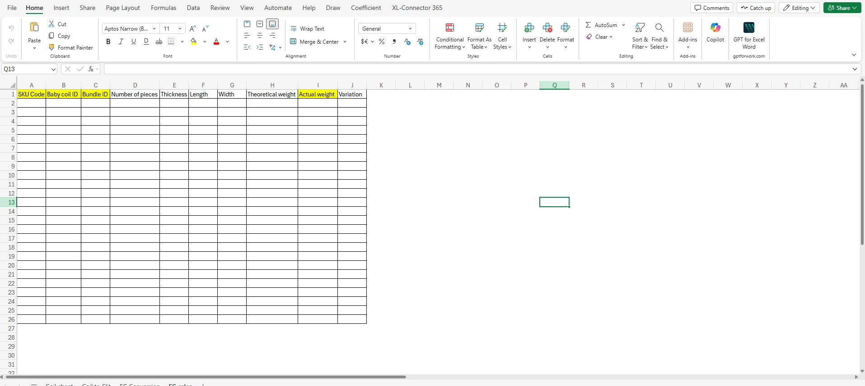

Variation Analysis:
Negative Variation (Red): Indicates weight loss due to:
- Processing scrap
- Cutting waste
- Edge trimming
- Material defects removed
- Measurement differences

Critical Process Notes:
- Always verify actual weight using calibrated weighbridge before dispatch
- Variation data feeds directly into Yield Calculation (Section A.6)
- Consistent negative variations may indicate process inefficiencies requiring investigation
- Large variations (>5% of theoretical weight) should be flagged for quality review
- This data provides complete traceability from raw material (HR Coil) to finished product dispatch

A.6 Yield & Loss Calculation
This section describes the methodology for calculating manufacturing yield based on the variation between theoretical weight and actual weight recorded during the FG sales/dispatch process. Yield calculation is critical for measuring process efficiency, overall conversion efficiency, and identifying areas for improvement. The variance analysis enables better production control and cost analysis.
Activity | Steps | Team | Interface / Utilities Used
6. Yield & Loss Calculation & Analysis | 1. Open Pipes_and_Tubes-Operations.xlsx file  2. Navigate to "FG sales" tab  3. Review Variation column data for all dispatched bundles  4. Calculate Individual Bundle Yield:  Bundle Yield (%) = (Actual Weight / Theoretical Weight) × 100  5. Calculate Aggregate Yield for reporting period:  Period Yield (%) = (Total Actual Weight / Total Theoretical Weight) × 100  6. Analyze yield by:  • HR Coil batch  • Baby Coil  • SKU Code  • Production date/period  • Operator/shift  7. Identify patterns in yield loss  8. Calculate material loss:  Material Loss (kg) = Total Theoretical Weight - Total Actual Weight  Material Loss (%) = (Material Loss / Total Theoretical Weight) × 100  9. Document findings in yield analysis report  10. Recommend corrective actions for:  • Yield < 95%: Minor process optimization needed  • Yield < 90%: Significant process investigation required  • Yield < 85%: Immediate corrective action required  11. Track improvement over time  12. Update process documentation based on findings | Planning team | Pipes_and_Tubes-Operations.xlsx  All sheets for comprehensive analysis  

Yield Calculation Formulas:
Metric | Formula
Bundle Yield | Yield (%) = (Actual Weight / Theoretical Weight) × 100
Material Loss (Weight) | Loss (kg) = Theoretical Weight - Actual Weight
Material Loss (Percentage) | Loss (%) = (Material Loss / Theoretical Weight) × 100

Yield Benchmarks & Action Triggers:
Yield Range | Status | Action Required
≥ 98% | Excellent | No action required, maintain current process
95% - 97.9% | Good | Monitor for trends, minor optimization opportunities
90% - 94.9% | Moderate | Process investigation required, identify root causes
< 90% | Poor | Immediate corrective action, halt production if necessary

Key Performance Indicators (KPIs):
- Overall Manufacturing Yield: Target ≥ 96%
- Slitting Yield (HR Coil to Baby Coil): Target ≥ 98%
- Conversion Yield (Baby Coil to FG): Target ≥ 95%
- Material Loss Rate: Target ≤ 4%
- Scrap Generation: Target ≤ 3% of input weight

Common Causes of Yield Loss:
- Edge trimming and width adjustments during slitting (1-2% typical)
- Length cutting waste (0.5-1% typical)
- Quality defects requiring removal (0.5-1.5% typical)
- Surface conditioning and finishing (0.3-0.8% typical)
- Measurement and weighing variations (0.1-0.3% typical)
- Material handling and storage losses (0.1-0.2% typical)

Yield Improvement Actions:
- Optimize slitting parameters to minimize edge waste
- Implement length optimization software for cutting schedules
- Enhance quality control at HR coil receipt stage
- Regular calibration of weighbridge and measuring equipment
- Operator training on material handling best practices
- Review and update SKU specifications to match coil dimensions

Critical Notes:
- Yield calculations must be performed daily for immediate visibility into process performance
- Monthly yield reports should include trend analysis and corrective action tracking
- Yield data should be reviewed in production meetings to drive continuous improvement
- Significant yield deviations (>5% from target) require root cause analysis within 24 hours
- Yield improvement initiatives should be tracked with measurable targets and timelines

